CMPUT 302
Human Computer Interaction
Project Design
Interactive Surface - Target Tapping

By: Adam, Shawn; Boutet, Patrick; Padlesky, Aaron; Santos, Eddie
Motivation And Goals:
From the start of this project, each group member had some unique motivation and goals; simultaneously, the group as a whole shared some of the same motivations and goals. Our first motivation was that the client was from outside the University; this meant our application had usage potential in the outside world. A second motivation was to create a non-trivial touch-based interface, which we had hoped to do. As of now, our project is at the halfway point, and some of our motivations and goals have altered. Most of us had the motivation to use C#, the XNA game framework and work with a touch interface. We have become more comfortable with C# and the XNA framework and our motivations and goals have shifted to improving our skills and abilities within the XNA framework and C#. Currently we have still have very little hands-on experience with the touch hardware itself, but those of us working on the frontend creating the GUI have gained invaluable experience at designing a user interface to be used with touch hardware, as well as designing GUI elements capable of handling mouse and touch input.
The project itself consists of a touch-enabled table that will be capable of displaying objects (shapes, numbers, and letters) of which a disabled person can attempt to touch. The purpose of this is to allow patients to regain mobility and coordination. Our application will provide what we refer to as a level editor, this allows therapists to layout the objects and specify their size, color, shape, and position. These layouts, referred to as levels, can be saved and loaded for use in future therapy sessions with patients. It is our opinion this design for the application is a well formulated model, and can be quite beneficial for all future users.
During our first couple meetings we discussed many of the goals we have. Our first goal was to simply make a program and tool that therapists want to use. More specifically what we are hoping to achieve is to provide a high-quality interface that is simple and intuitive. Currently we feel we are on track to meet this goal, which is very exciting. We have also debated which direction we would like to take this project, for a while our group of four was split on our ideology towards implementing this system. On the one hand we wanted to make a program that would give therapist all the tools they could ever dream about, on the other hand, we stressed simplicity. Moving forward we chose to favor simplicity and quality over having a larger feature set. Simplicity is evident throughout all our working prototypes so far. With this as a leading design goal we feel the client will be presented with an application that cannot fail to meet their needs, and the future users will be delighted with the ease-of-use. The potential this application has to aid future patients in rehabilitation is high, and we are pleased to be the ones developing this tool.
We have used sub-goals to help us hopefully achieve our end goals as well. Intuitiveness is our first sub-goal. “Intuitiveness” means that the therapist using our application can look at the interface and immediately know how to work the application; currently we feel this is the case. We want to minimize the use of complicated menus and feel this has already been achieved. We want the user interface to guide the therapist in how to set up the right game for the patient. For the patient then, we want their interface to be simple and solid. We realize that the patients will have a variety of health conditions ranging from coordination problems to having very limited mobility and/or cognitive ability; therefore we seek to eliminate the possibility that the patient may perform accidental actions within the system. This sub-goal has yet to be achieved, but we have a well-formulated plan to achieve this goal. Our next sub-goal is to create an appealing GUI for the client and patient. We understand exorbitant amounts of detail may overwhelm the patient rather then delight the patient. As such, all of our graphics are very simple, yet appealing and professional looking. Another sub-goal is to favor ease of learning over everything else. This means we want all therapists to master using the game/application. We will not implement un-needed features, and will continually think of how to make every part of the user interface as simple to use as possible, just as we have up until now. One very specific sub goal we set was at no point in our programs execution should there ever be a need for keyboard or mouse and this has also been achieved.
We have a second set of goals. These goals refer to development. Our first goal was to have working prototypes available very early on in development; we feel this was a success. We hope that we have the right motivations, and set the right goals for ourselves to develop a quality game to the user and at this point in time we feel we do.

Interaction Design:
The following pages area mockup of our user interface in the context of multiple use cases. Currently, our implemented UI follows these exact layouts. Some minor changes have been made for implementations sake, but on the whole, up until now, we feel we have successfully implemented our UI both theoretically and in practice.

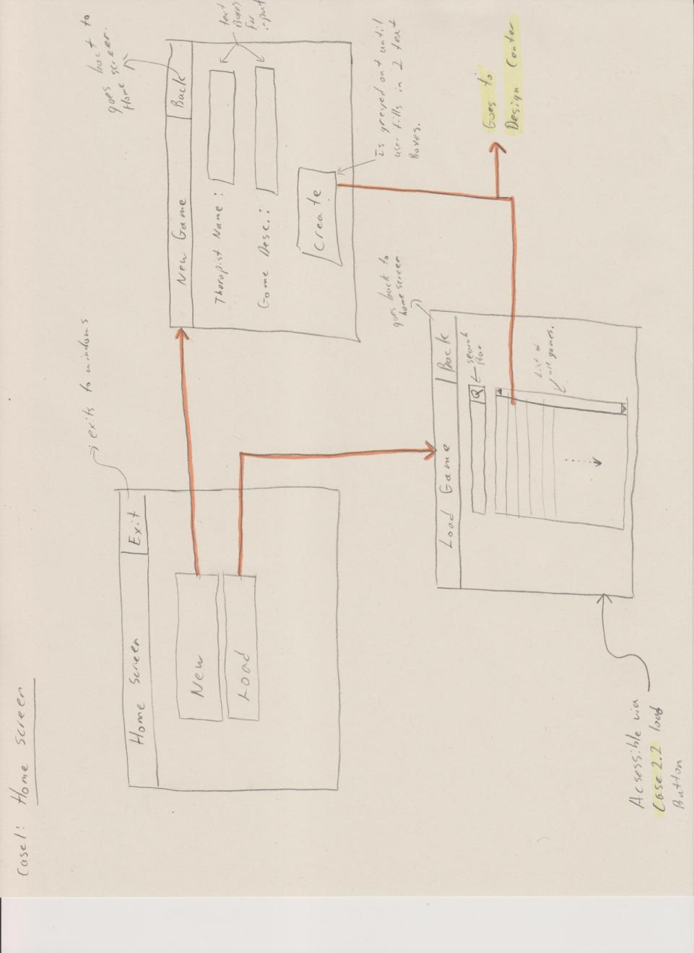
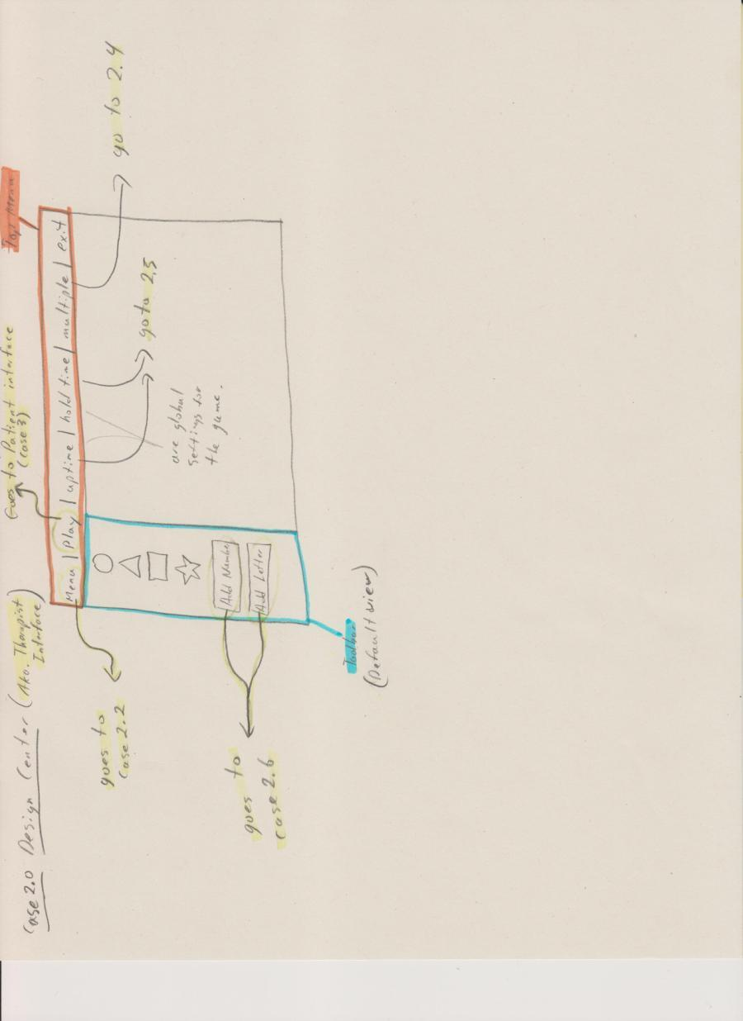

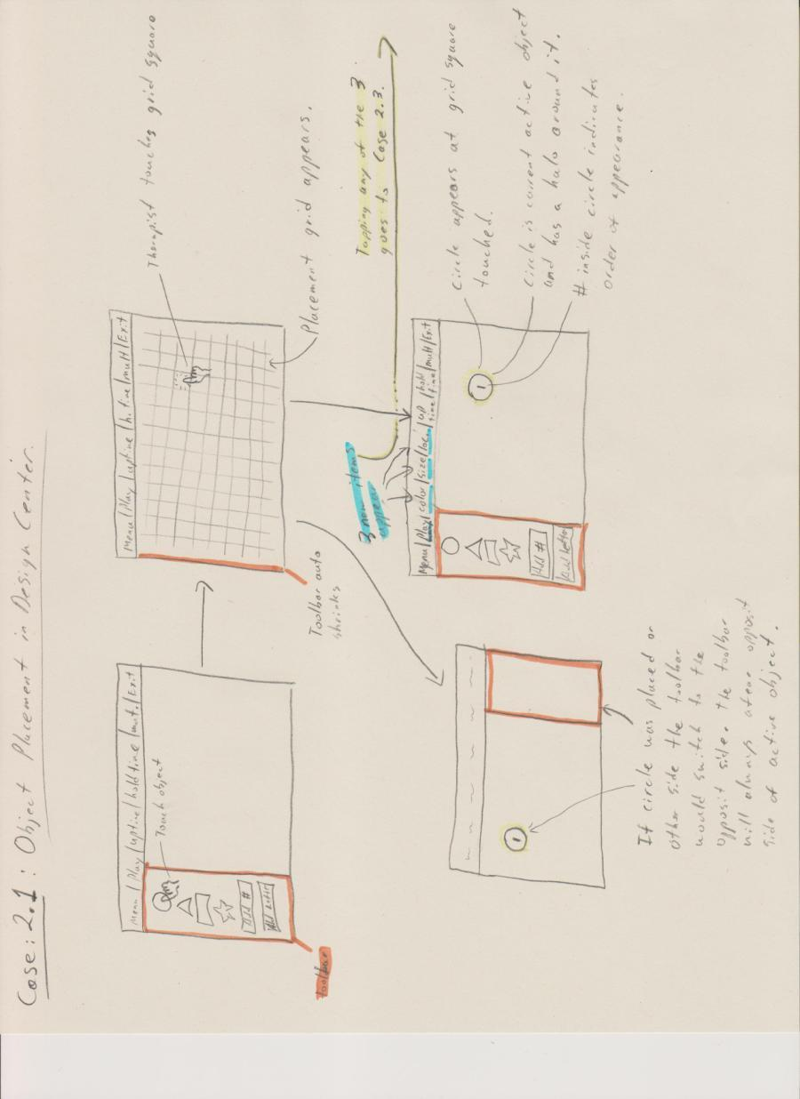

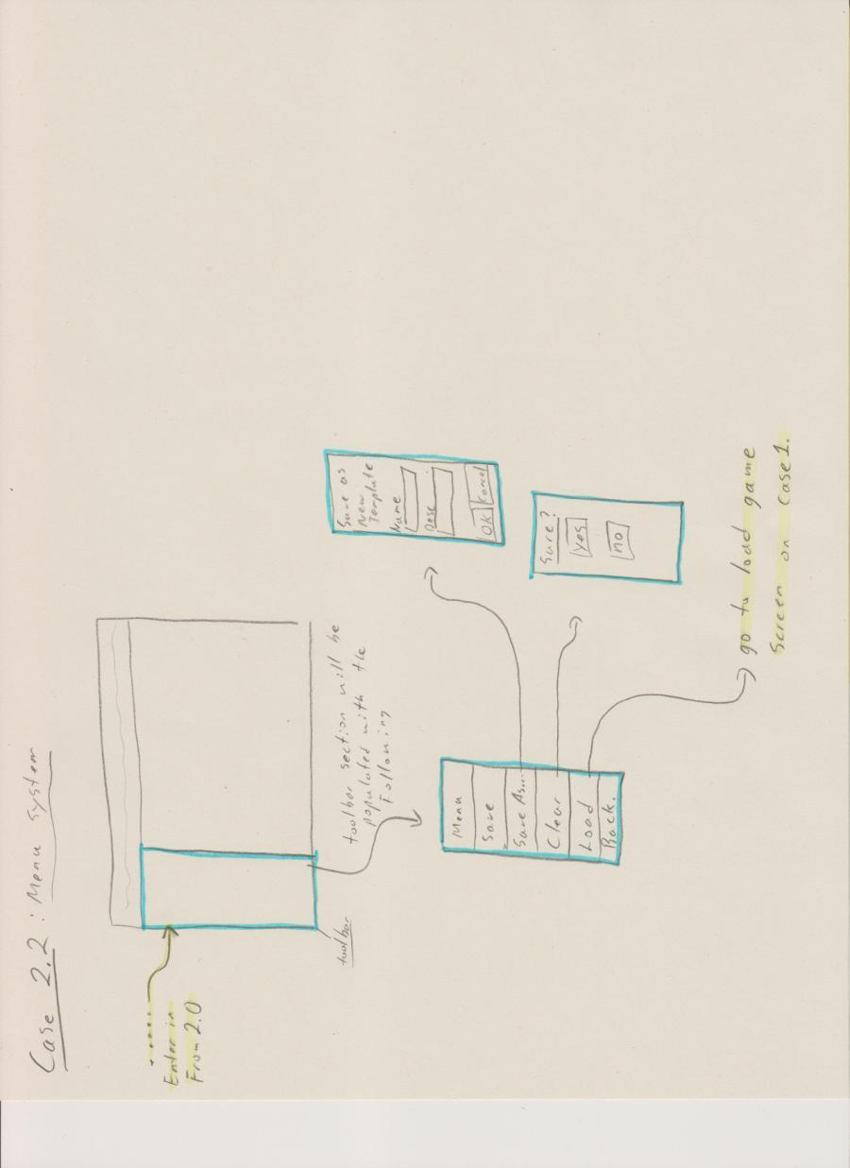

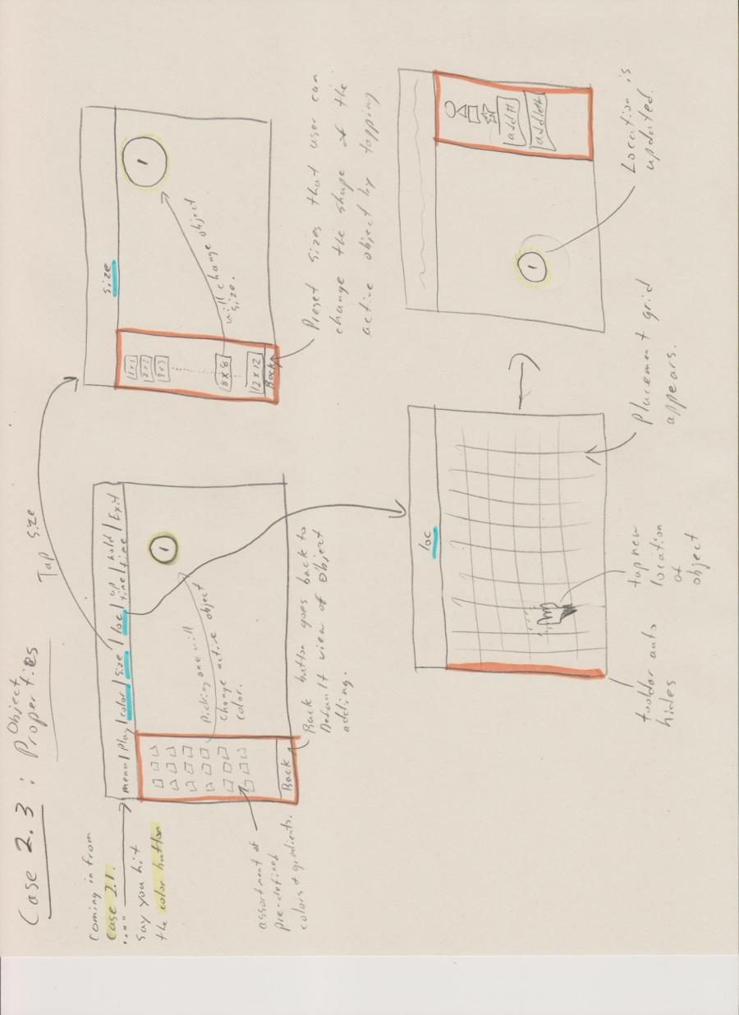

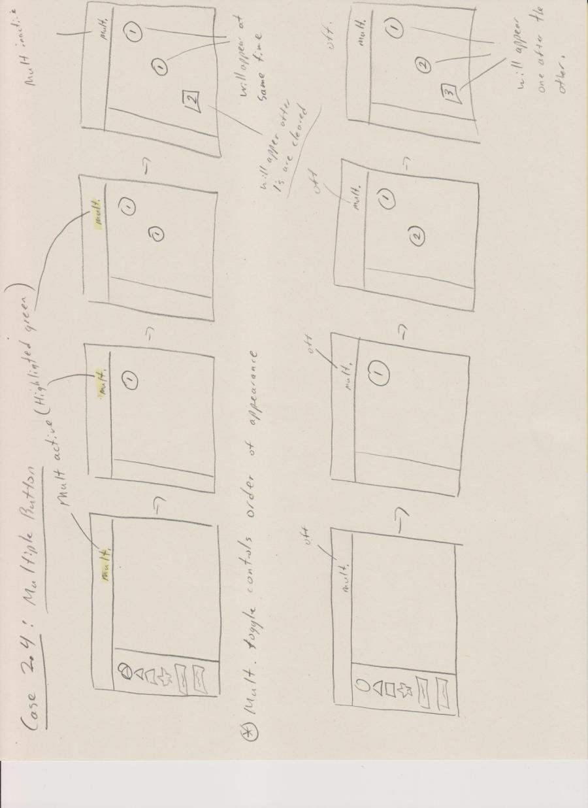

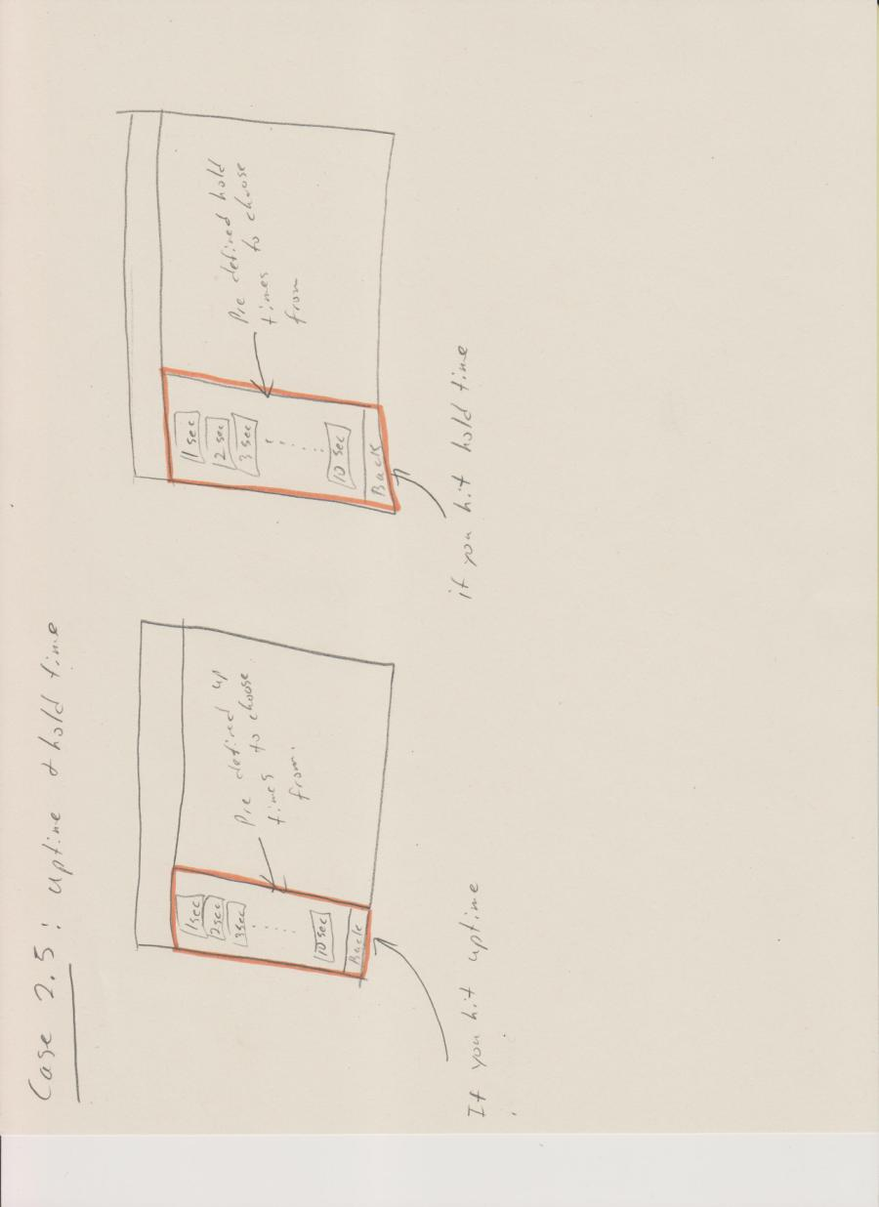

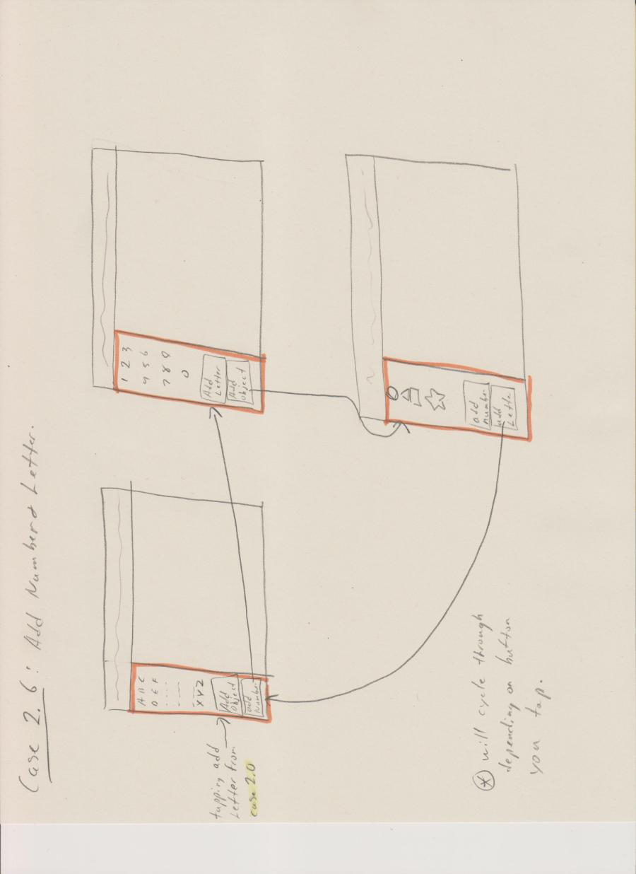

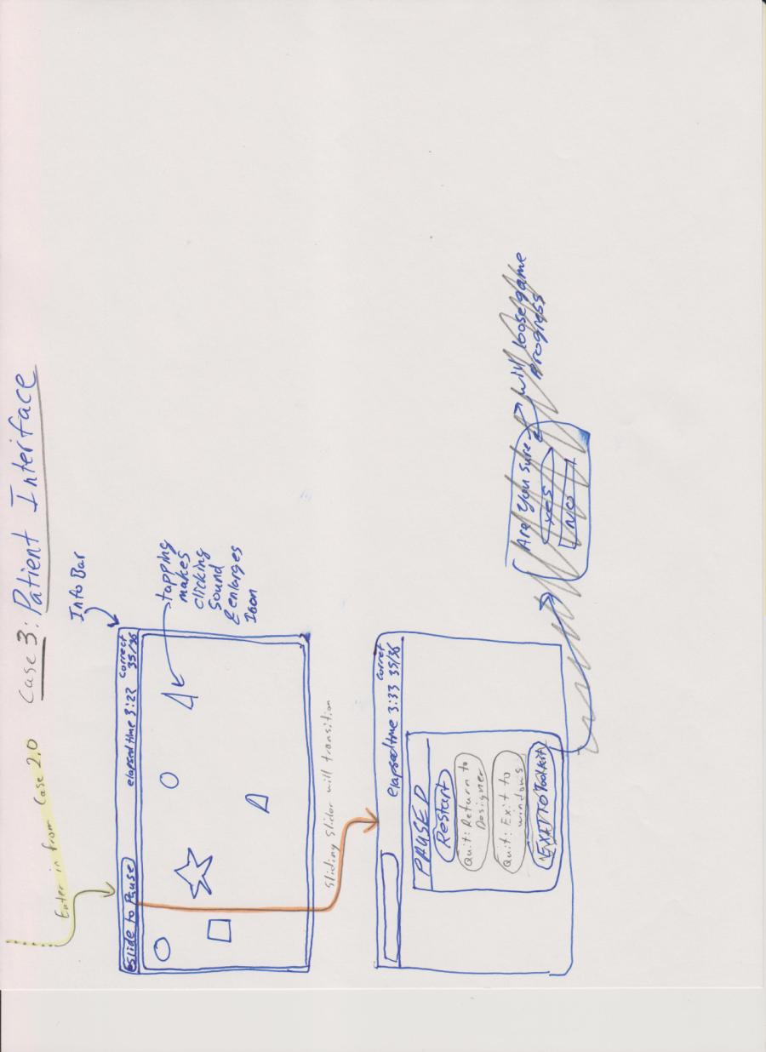

System Design:
This application deliverable will be required to install and work alongside the Windows 7 operating system. We have been using C# and the XNA framework to implement the deliverable. Hardware will consist of a PC running windows 7, and a custom designed touch screen tablet. Up until now development has taken place inside the Windows 7 and Windows 8 OS and we have experienced no issues with cross compatibility on the operating systems. The tablet is constructed from a large flat screen LCD TV with 1080P screen resolution, currently our application uses 720p resolution so we could program on our laptops, when the application is nearly ready for delivery, we will optimize for 1080p resolution. The television speakers are connected to the PC, which allows us to implement audio feedback, which is currently on our to-do list. Supporting the television physically is a desk-like custom device that is capable of many adjustments. A custom touch screen is positioned directly on top of the televisions screen. Full touch integration enables the application once it is loaded, to appear self-contained inside the touch device, having no need for peripheral devices. Our goal is to give this custom application the feel of a stand-alone tablet, which many people are now becoming quite familiar with.
The application itself has two main states; these states will be referred to as the patient interface and the therapist interface. The patient interface is very simple and intuitive. Essentially the only interactions available inside the patient interface are to tap/tap&hold the symbols that will be used for patient rehabilitation; and to slide across the menu bar to pause the game. The slide-to-pause currently is implemented as a standard button, but this will be amended. Upon pausing the game from the patient interface a menu appears giving options to the user on how to proceed next. The other side of the application is the therapist interface. The therapist interface allows the user to start the game for the patient. As well, from here the therapist can load previously saved game configurations, and create new game layout configurations. Levels will be saved as stand alone xml files, and will be accessible from the in game browser.
The touch interface will soon have feedback added, such as sounds and visual events when objects are touched. The display of the TV will be the intended application to view the interface. Therefore we will optimize the game to be displayed in 1080P (1920x1080) resolution, it currently is optimized for laptops at 720p resolution. In full screen mode currently the resolution makes the interface appear slightly fuzzy, but maintains formatting. To remove complications with peripheral devices we use an on-screen touch keyboard whenever input is required from the user for labeling.
Implementation Details:
Our application is split into a frontend and backend: The frontend contains a screen manager, which controls what is displayed at any given time. Graphical objects such a buttons and labels use XNA's Texture2D as their image, and these are drawn to the screen. A button class allows us to capture touch/click events and trigger actions from those events.
The backend is designed to draw/move shapes throughout the placement grid, as well as maintain information on what comprises these images, such as color, size, position, and overall shape. The backend as well contains the ability to save and load previously created layouts.
A large collection of bitmap images have been drawn for display in the application. This includes mainly button graphics and label graphics. Sizes are subject to change once we switch to 1080p resolution and test on a full size TV. Graphics found inside the patient game will be dynamically created by classes written to handle dynamically changing graphical images.
We are currently using libraries all supplied by Microsoft. This includes the XNA 4.0 game framework, and built in libraries for C# to handles strings, math and more. Code has not been taken from any third parties at this time except from http://www.youtube.com/watch?v=54L_w0PiRa8 which explains how to use a menu system. Code was also supplied by our client, Michael Cimolini. His game template that is known to work on the actual hardware was used for compatibility. Indeed, his game template also proved useful for organizing and structuring our code.
Lastly, in order to help organize our code we have divided our classes into several packages that group similar functionality or closely tied classes together. In general we have a frontend package, a backend package, and a content folder filled with sub-folders of graphical content.

Proposed Empirical Evaluation:
In our project development we plan to have a functioning prototype with all required features completed long before the delivery date of the system. With this functioning prototype one of our objectives is to have it tested in a qualitative way by a therapist that will be a potential user. Our objective is to first understand how well the user can infer the usage and the features of the program. After we evaluate the user's ability to use the system without help, we will request they rate the systems usability and learnability on a scale from 1 to 10. For half of the subjects, we will explain the system and how we intend it to be used; the other half of the subjects will have a filler task. After this we will give them another chance to explore and use the system, and once again get them to make a rating. If we find that the system's usability and learnability is sufficient, based on the data, we will feel quite confident in our design and move on to more quantitative testing. If however they find the usability of the system to be unacceptable without first being explained the system, and once again find it difficult after explanation we will have to seriously re-evaluate the design. However either way we will be asking those users who tested the system what kinds of changes, additions, or removals to the system would be helpful to aid in ease of use.
As mentioned above, if our qualitative testing is successful we will attempt more rigorous quantitative test methods. We will gather approximately 20 users worth of data; these users will be general population as for this test they simply have to be unfamiliar with the interface we designed which would be an identical situation to a therapist using it for the first time. We will write test code into the program that is able to track the time between different actions. We will then explain how to do an action, such as create a new design template, change an objects color, size, or location, etc… The user will then attempt the action and the code will track their time. Once we have time data on actions from general users we will perform the same tests but with ourselves as experts on the interface. We can then take the average time of the users (beginners) and compare it to our average x 2 (experts) via a t-test. Then see how different the two data sets are and based on if we see a statistical difference or not make two conclusions. First is if there is a difference between the two data sets (the t-test would lead us to take the alternative hypothesis) then we may conclude that our interface is not as intuitive as we would like it to be and take the effort to find out what the roadblocks for users are. Second is if there is no difference between the two data sets (the t-test will lead us to take the null hypothesis) then we can say that we have built a very intuitive interface with a low learning curve. Overall we want to test how long it takes the users to figure out the user interface instead of how to use it.

Risk Management:
After meeting with our client, and determining many of the requirements for this system we have identified risks that could jeopardize the success of our project. The lack of access to the hardware poses a risk. With less time to test on the actual hardware it is possible to miss bugs when we have to rush through testing when the hardware is accessible. We have been assured however that mouse and keyboard testing will be quite accurate and representative of the performance of the real hardware. We have also asked our client to test our code on the hardware when he is available. To lower this risk further, on the days we do have access to the hardware we will plan our tests and be prepared to maximize efficiency. We plan to have a working prototype ready early on, and always strive to meet the important requirements first. This will make sure our code works correctly on the hardware long before the deliverable deadline. If we have a strong basis to work from, we feel we can limit the risk of nearing the deadline and being forced into a rush to accomplish functionality. To monitor all these risk we will constantly re-evaluate and discuss risks, always looking to identify new risks. We will post all risks to the wiki, and monitor their probability and effects.

Project Schedule:
To make sure we meet the deliverable deadline we have thoroughly thought through a schedule we plan to follow faithfully. We plan to have a solid functioning prototype at the half waypoint we have set. This will make sure we have the main requirements as well alleviate last minute stress. To limit the possibility of unexpected delays affecting the completion of the project we have set all main requirements to be met as soon as possible. In this way we plan to develop the system in layers. First meeting main requirements, then adding layers of functionality and performance. We have set many milestones and many tasks that will allow us to achieve said milestones. One is to develop custom aesthetic graphics for the application. The front end will consist of 5 main milestones. The menu bar and grid inside the patient interface; and menus, design screen, and home screen inside the therapist interface. These larger milestones will include smaller tasks inside their development. On the backend we have set the ability to create levels, the ability to save levels, the ability to process touch, the menu backend, event handling and object creation all as milestones. Again these milestones will have smaller self-contained tasks that do not cut as widely across the application. Deliverables include project design, ethics, prototype 1, the final product, and all code documentation and design documentation.
The above deliverables, milestones and their affiliated tasks have been laid out in the below Gantt chart which specifies specific dates and durations for the project.
Please see attached external GANTT chart.

